ОТЧЕТ

По дисциплине «Основы информационной безопасности»

Студента 2 курса группы БИСО-03-19

Тепсикоева Солтана Артуровича

РТУ-МИРЭА 2020

Задание 1.

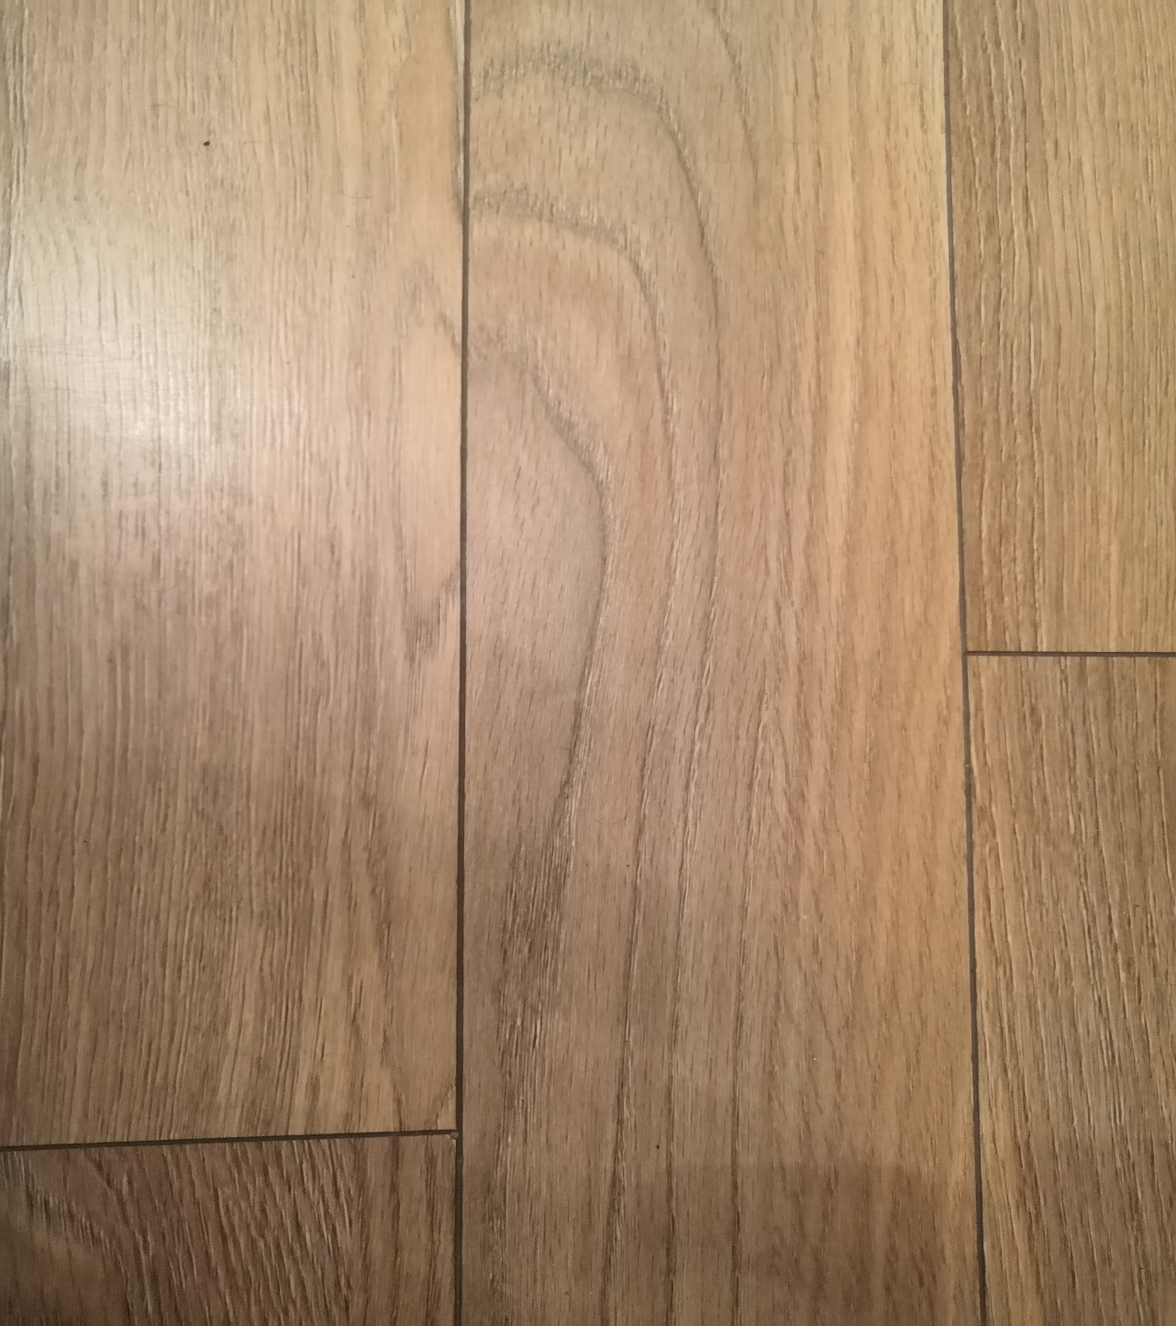

Мною была сделана фотография пола со включенным геотегом. Вот данные ExifTool:

|  |  |
| --- | --- |
| ExifTool Version Number | 12.07 |
| File Name | 1.jpg |
| Directory | . |
| File Size | 4.3 MB |
| File Modification Date/Time | 2020:10:21 17:10:47-05:00 |
| File Access Date/Time | 2020:10:21 17:11:22-05:00 |
| File Inode Change Date/Time | 2020:10:21 17:11:22-05:00 |
| File Permissions | rw-r--r-- |
| File Type | JPEG |
| File Type Extension | jpg |
| MIME Type | image/jpeg |
| Exif Byte Order | Big-endian (Motorola, MM) |
| Make | HUAWEI |
| Camera Model Name | COL-L29 |
| Orientation | Unknown (0) |
| X Resolution | 72 |
| Y Resolution | 72 |
| Resolution Unit | inches |
| Software | COL-L29 10.0.0.177(C10E4R1P4) |
| Modify Date | 2020:10:21 22:06:34 |
| Y Cb Cr Positioning | Centered |
| Document Name |  |
| Exposure Time | 1/25 |
| F Number | 1.8 |
| Exposure Program | Program AE |
| ISO | 800 |
| Exif Version | 0210 |
| Date/Time Original | 2020:10:21 22:06:34 |
| Create Date | 2020:10:21 22:06:34 |
| Components Configuration | Y, Cb, Cr, - |
| Compressed Bits Per Pixel | 0.95 |
| Shutter Speed Value | 1/999963365 |
| Aperture Value | 1.8 |
| Brightness Value | 0 |
| Exposure Compensation | 0 |
| Max Aperture Value | 1.8 |
| Metering Mode | Multi-segment |
| Light Source | Daylight |
| Flash | No Flash |
| Focal Length | 4.0 mm |
| Warning | [minor] Unrecognized MakerNotes |
| Maker Note Unknown Text | Auto |
| Sub Sec Time | 333029 |
| Sub Sec Time Original | 333029 |
| Sub Sec Time Digitized | 333029 |
| Flashpix Version | 0100 |
| Color Space | sRGB |
| Exif Image Width | 3456 |
| Exif Image Height | 4608 |
| Interoperability Index | R98 - DCF basic file (sRGB) |
| Interoperability Version | 0100 |
| Sensing Method | One-chip color area |
| File Source | Digital Camera |
| Scene Type | Directly photographed |
| Custom Rendered | Custom |
| Exposure Mode | Auto |
| White Balance | Auto |
| Digital Zoom Ratio | 1 |
| Focal Length In 35mm Format | 27 mm |
| Scene Capture Type | Standard |
| Gain Control | None |
| Contrast | Normal |
| Saturation | Normal |
| Sharpness | Normal |
| Subject Distance Range | Unknown |
| Device Setting Description | (Binary data 4 bytes) |
| Compression | JPEG (old-style) |
| Thumbnail Offset | 8630 |
| Thumbnail Length | 26179 |
| JFIF Version | 1.01 |
| Image Width | 3456 |
| Image Height | 4608 |
| Encoding Process | Baseline DCT, Huffman coding |
| Bits Per Sample | 8 |
| Color Components | 3 |
| Y Cb Cr Sub Sampling | YCbCr4:2:0 (2 2) |
| Aperture | 1.8 |
| Shutter Speed | 1/25 |
| Create Date | 2020:10:21 22:06:34.333029 |
| Date/Time Original | 2020:10:21 22:06:34.333029 |
| Modify Date | 2020:10:21 22:06:34.333029 |
| Thumbnail Image | (Binary data 26179 bytes) |
| Image Size | 3456x4608 |
| Light Value | 3.3 |
| Megapixels | 15.9 |
| Scale Factor To 35 mm Equivalent | 6.8 |
| Circle Of Confusion | 0.004 mm |
| Field Of View | 67.4 deg |
| Focal Length | 4.0 mm (35 mm equivalent: 27.0 mm) |
| Hyperfocal Distance | 1.97 m |